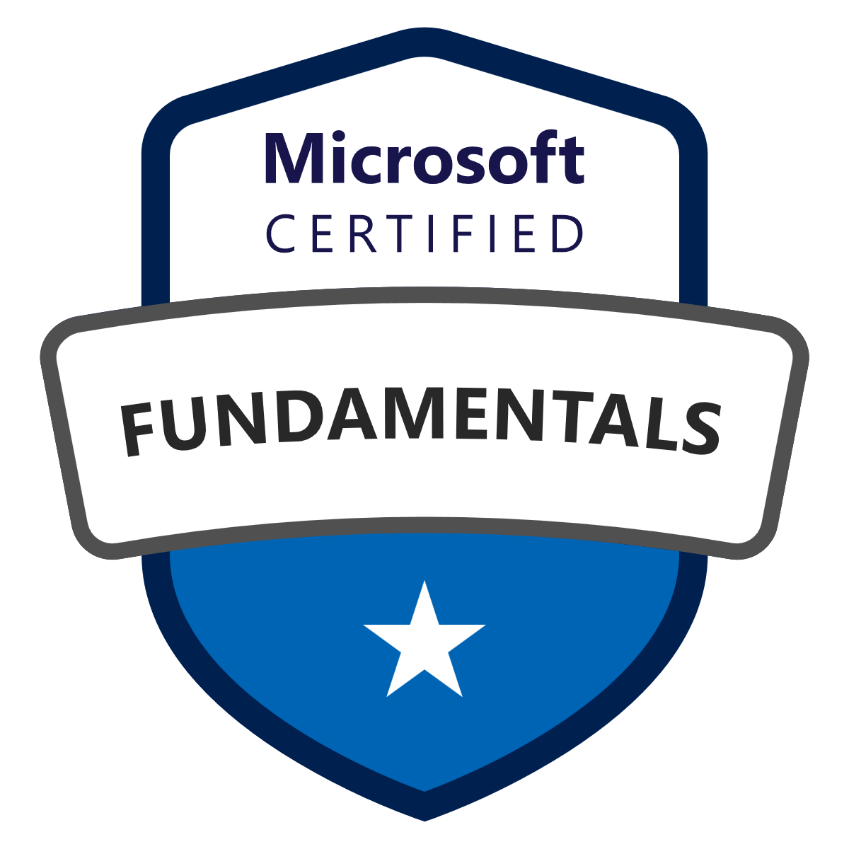

**KALA MAROJU**

**E-mail:Kalamaroju@gmail.com Ph: 443-851-1443**

**____________________________________________________________________________________________**

**Professional Summary:**

* **Azure** and **ISTQB** Certified Software Tester with **10 years** of experience in **Manual** and **Automation** Testing of **Client/Server** and **Web** applications, and a strong understanding of the Software Development Life Cycle (**SDLC**).
* Extensive experience working in various domains like **Financial**, **Healthcare** applications.
* Tested web applications in different methodologies like **Waterfall** and **Agile** development processes.
* Extensive experience in developing **Test Plan, Test Cases, Test Scenarios, Test Scripts, Test Execution,Test Metrics, Test Reports and Defect tracking**.
* Proficient in using **QC/ALM**, **Team Foundation Server** and automated tools like **Selenium WebDriver,TestNG ,Cucumber, IntelliJ, Quick Test Pro**/**Unified Functional Testing**.
* Proficient in **Functional, Integration Testing,** **Regression, System Testing, GUI, Stress, Smoke Testing, End-to-End Testing**.
* Expertise in **Manual** , **Mobile App and Automated** Testing, Recording, Debugging, Customizing, Test Planning, Managing Requirements, Defect Tracking and Reporting and running scripts**.**
* Performed Manual Mobile Testing using **Emulators**.
* Wide knowledge of section **508** testing tools **Jaws and SureSite.**
* Solid understanding and experience in **White box** and **Black box** testing**.**
* Worked in the **Agile** development environment with frequently changing requirements and features set.
* Experience in Continuous integration tools like **Maven, Jenkins**.
* Hands on Experience in testing **REST** services using **Postman.**
* Worked with **Target Process**and **Version One** to track the testing activities & progress of a project.
* Proficient in working with databases like **SQL Server 2000/2005/2008/2012**, and in using data access technologies
* Good Working Knowledge of **database** which includes: **creating tables, indexes and triggers, writing stored procedures, views** using **SQL**.
* Good Exposure in testing SOAP Web services by using **SOAP UI Pro** tool.
* Strong exposure to SDLC models like Agile-Scrum models.
* Working experience on Data driven and Keyword driven frameworks in QTP.
* Excellent knowledge in testing applications developed in **.NET,  XML, HTML, JavaScript ,JAVA** and **JSP**.
* Meets Testing schedules and Project timelines and Ability to handle multiple tasks works independently and as well as in a team
* Excellent Organization, Analytical, Problem solving, Decision making, Ability to quickly learn new technologies and Presentation skills.

**Academic Qualification:**

* M. Sc (Computer Science) from Osmania University, India.-2002 to 2004(Graduated in 2004)
* B. Sc (Computer Science) from Kasturba Gandhi College for Women (O.U), India.-1999 to 2002(Graduated in 2002)

**T****echnical skills:**

|  |  |
| --- | --- |
| Testing tools: | UFT ,Selenium, TestNJ,JUnit,MTM, Quality Center, ALM ,Postman, Rest Assured, SoapUI Pro ,Team Foundation Server, Load Runner, Quick Test Professional (QTP),. |
| Operating Systems: | MS Windows, UNIX, Linux. |
| Databases: | Oracle 8i, 10g, 11g, Microsoft Access, Microsoft SQL Server2000/2005/2008/2012. |
| Programming Technologies: | C, C++,C#, Java, ASP.NET, Shell Scripting, SQL, ,XML, HTML, VB Script ,Descriptive programming , VC++, Microsoft .Net Framework, Visual Studio , Toad. |
| Scripting | JavaScript ,VBScript, WCF, Web Services, JSON, AJAX, JQuery, Web API Restful Services |
| Version Control | Visual SourceSafe, TFS |
| Agile Tools | Target Process,Version one |
| Utilities | Microsoft Excel, WinDiff ,MS Word |

**Certifications:**

|  |  |  |
| --- | --- | --- |
| **Azure Fundamentals** *Credential ID: 9FFBBA404CA8485B*  *Certification number: 133358-T65F4B* | **Microsoft Certified: Azure Fundamentals** | **Graphic 1** |
| **Test Automation Engineering Certification:** *24-CTAL-TAE-00198-USA* | **Certified Tester Advanced Level Test Automation Engineering (CTAL-TAE) (ASTQB)** Passed in 2024. | **Picture 1** |
| **QA Foundation Level Certification:** *17-CTFL-00072-USA* | **Certified Tester Foundation Level (CTFL)(ASTQB)**Passed in 2017. | **Picture 1** |

**Professional Experience:**

**Remedi Seniorcare ,MD Oct’18**

**Senior Quality Analyst(Automation Engineer)**

**Responsibilities:**

* Development and maintenance of test script based on the business rules and functional points.
* Designed, executed and maintained automated test suites and test cases using **Selenium WebDriver, TestNG** and **Maven**.
* Selected the test cases to be automated and performed functional testing of the front end using **Selenium WebDriver)** & created **Data driven framework .**
* Executed **parallel** testing on various machines using **Selenium** **Grid** and performed **cross browser** testing(chrome, Firefox, safari, explorer).
* **Designed and implemented CI/CD pipelines** using J**enkins**, automating build, test, and deployment processes to enhance software release efficiency.
* Integrated **Selenium-based** automated tests into **Jenkins** pipelines, enabling continuous testing and reducing defect leakage .
* Detailed testing reports of the Test Execution summary reports and Bugs found for developers and closing them after regression testing.
* Created and executed the test cases for various scenarios, and participated actively in **System**, **Integration, Functional** and **Regression** testing for every new build released.
* Hands on Experience in testing **REST** services using **Postman.**
* Good in **database testing** by using **SQL queries** retrieved the data from database for data validation to ensure Data integrity.
* Performed Data driven testing using Selenium WebDriver and **TestNG** functions which reads data from property and **XML** files.
* Experience in continuous Integration testing using **Maven,Jenkins, GIT.**
* Writing Test scripts using **Element locators,WebDriver methods and TestNG Annotations.**
* Developed Selenium test cases using T**estNG** framework
* Contributedin developing and organizing Automation Framework with structured Files and Folders .Framework implements using **Data Driven** ,**Page Object Model.**
* Extensively used **Target process** for logging defects.
* Designed and implemented **REST Assured** framework for API automation, validating request/response payloads, headers, status codes, and JSON/XML schema.
* Developed reusable utility methods for API requests (GET, POST, PUT, DELETE) to improve test maintainability and scalability.
* Integrated REST Assured tests into **TestNG** and Maven for streamlined execution and reporting.
* Parameterized API tests using external data sources for **data-driven API testing**.
* Incorporated REST Assured execution into **Jenkins CI/CD pipelines** for continuous API validation.
* Performed API performance and reliability testing by simulating concurrent requests.
* Assist in post -production such as end-user support ,Troubleshooting. Of issues on relevant production like environments.

**Environment:** Target Process,Selenium Web Driver,Test NG, Rest Assured, Android Emulator of UI ,Jenkins, Mobile Notification services ,SQL Server 2012,POM,Java ,SelectionsHub, Eclipse IDE,HTML ,JavaScript .

**Legal & General America Feb ’17 – Sept’18**

**Senior Quality Analyst (Automation Engineer)**

**Responsibilities:**

* Implemented the modular and Data-driven test automation methodologies within the test architecture framework.
* Used regular expressions for dynamically changing objects in the application used parameterization to create more reusable and robust scripts to validate data in runtime.
* Experience creating the classes, variables, methods, conditional statements, loops in C# language to implement Automation framework.
* Interviewed Developers to gain detailed information on complex calculations and analyze the application in order to write repeatable End-to-End test cases for the application.
* Worked with the Ranorex automation tool to implement data driven tests for different scenarios by using the Recorded modules, Code modules, Ranorex repository and the Ranorex Spy for Xpath to create the Automated script for Smoke Testing, End to End Regression Testing.
* Gathered the Test Input data. Test Input data includes Pre-condition,

Test Result, Test Regression data.

* Generated the pdf reports with screenshots for each screen and validations.
* Created Shared and Local Object Repositories in Ranorex.
* Implemented Data-driven tests with Ranorex along with validation using Attribute Reg, Return/Get Value Features.
* Responsible for the creating, enhancing and executing the automated test scripts using Ranorex.
* Identified common functions and created methods for the reusability.
* Testing process involved daily test activities through Agile Scrum 'stand up' meetings.
* Developed Automation test scripts by using Descriptive programming.
* Executed functional automation test scripts and test scenarios in multi environments.
* Involved in Sanity and Build verification testing for patch/new build.
* Located ,documented and reported defects in Mobile App testing (Android devices).

**Environment:** MS Visual studio (2017), SQL Server 2016, Windows 2008/2012, Subversion, C#, .Net ,Ranorex 8.2 ,JIRA .

**FirstServiceNetworks, MD Feb '15– Jan ‘16**

**Quality Analyst(Automation Engineer)**

**Responsibilities:**

* Testing process involved daily test activities through Agile Scrum 'stand-up' meetings.
* Implemented **Behavior Driven Development** Framework with **Cucumber** andthe creation of Feature files with Scenario outline files**.**
* Exported test case scripts in Eclipse IDE and modified the Selenium scripts and executed ;Prepared automation test framework(Maven).And worked on acceptance testing using Cucumber.
* Performed different testing task using various test scripts on Selenium WebDriver and Junit.
* Executed multiple feature files in the **Test Runner** utilizing the **JUnit** framework.
* Developed new test case for every sprint and working with developers to automate their feature.
* Communicated **test progress, test results** to project stakeholders and management.
* Designed and developed **UAT Regression automation script** and **Automation of functional testing** framework for all modules using **Selenium WebDriver** .
* Good in **database testing** by using **SQL queries** retrieved the data from database for data validation.
* Responsible for communicating with developers on daily basis regarding bug fixes, enhancements, and program changes.
* Interacted with developers on open issues and driven the issues until closure.
* Presented the project status/results on daily and weekly basis in the Project Meetings.
* Analyze all Report Bugs for continuous process improvement and keep tracking on the SDLC critical path.
* Used TFS (Team Foundation Services)for defect Management.
* Used **SOAP UI** to validate the response of web services with the data in Host.
* Played a major role in project review meetings and updated bug status reports.

**Environment :** MS Visual studio (2013), SQL Server2012,Windows 2008/2012, TFS,Selenium Web Driver,TestNG,POM,Java ,WCF ,Web services ,SelectionsHub,Eclipse IDE,HTML ,JavaScript .

**ECIL ,India Jan 2005 - Jan 2008**

**.Net Developer**

**Responsibilities:**

* Involved in server side and client side programming.
* Involved in successful installation of the project .

**Module # 1 : Initptab**

Role: Involved in coding

**Module # 2 : DBSERVER**

Role: Involved in coding

**Module # 3 : SQLDLL**

Role: Involved in Database Programming

**Module # 4 : OPTASK**

Role: Involved in designing the picture files using Mimic Generator Tool.

and programming for display of data in Graphical Trend’s, Tabular Trend’s, 30 days Graphical and Tabular History.

**Module # 5 : TCPServer**

Role: Involved in socket programming for communication between active and standby server**.**

**Module # 6 : IOTCPServer**

Role: Involved in socket programming for communication between active/standby server and Display Nodes(Systems).

**Environment:** ASP 2.0, ASP.NET, C#, .NET Framework 2.0,3.5, Visual Studio 2005, XML, Web Services,, SQL Server 2005,Java Script, Win Forms, WCF MS Office and Windows 2000 Server.